HANOI UNIVERSITY OF SCIENCE AND TECHNOLOGY

School of Information and Communications Technology

Software Requirement Specification

An Internet Media Store

Subject: Software design and construction

Group 21

Student name: Ta Tien Thanh

StudentID: 20194176

*Hanoi,* *<12, 2023>*

Table of contents

Table of contents 1

1 Introduction 2

1.1 Objective 2

1.2 Scope 2

1.3 Glossary 2

1.4 References 2

2 Overall requirements 3

2.1 Actors 3

2.2 General use case diagram 3

2.3 Lower-level use case diagrams 3

2.4 Business processes 3

3 Detail requirements 4

3.1 Specification of Use case UC001 - “<Use case 1 name>” 4

3.2 Specification of Use case UC002 - “<Use case 2 name>” 5

4 Supplementary specification 7

4.1 Functionality 7

4.2 Usability 7

4.3 Reliability 7

4.4 Performance 7

4.5 Maintainability 7

4.6 Design Constraints 7

# Introduction

## Objective

This document presents the detailed description for Find Product subsystem for case study An Internet Media Store(AIMS). This document also describes the objectives and features of the system, interfaces and constraints of the system in response to external action.

This document is for stakeholders and related software developers.

## Scope

In this subject scope, we focus on the feature related to Find Product by customer in AIMS Project instead of others features.

## Glossary

## References

# Overall requirements

## Actors

* Customer: Main actor of this subsystem, interact with system with all feature, especially product finding in this document

## General use case diagram

* Customer can find product by three methods: Find product by search, Find product by category, Find product by price range. Customer can use all of these methods at the same time and the results of available products will meet all these conditions. Ỏ otheri

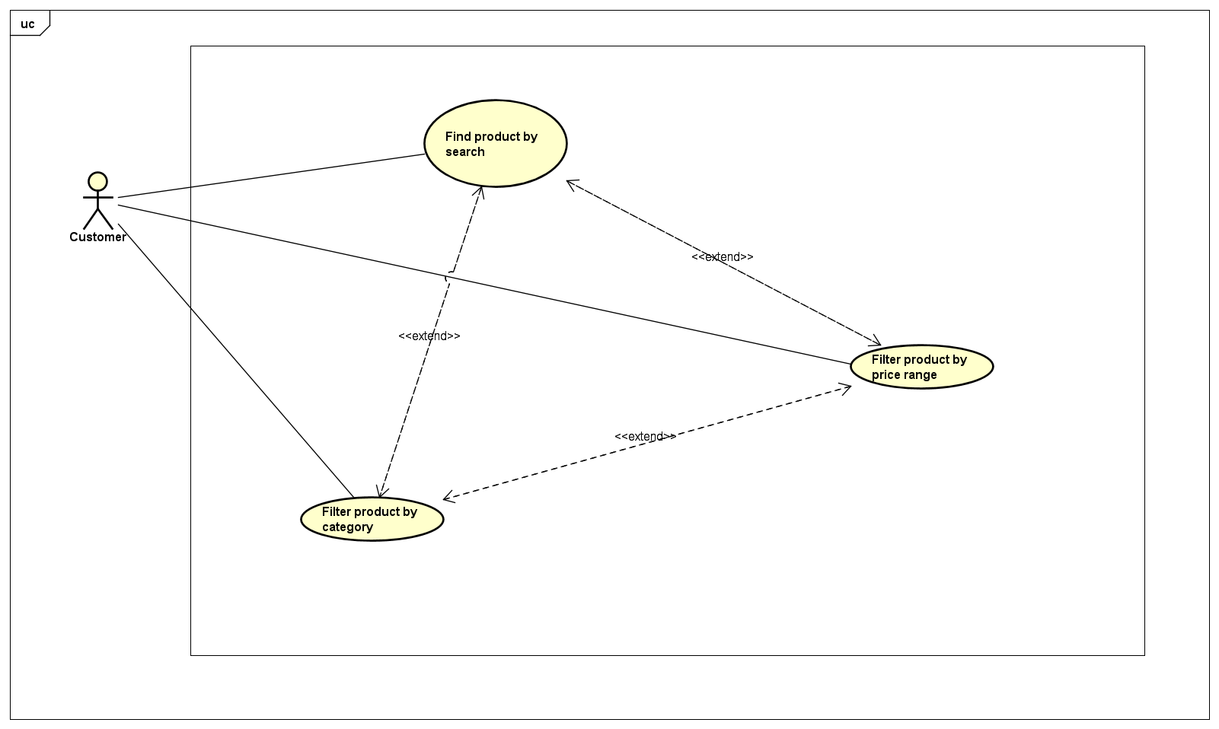

## Lower-level use case diagrams

* In lower-level use case Find product by search, customer can use search bar. When customer input searchbar, system will return the results for available product with name or others information of the product included author, publisher (for book); artist, record label(for compact disc or long-play record); director, studio(for digital video disc).

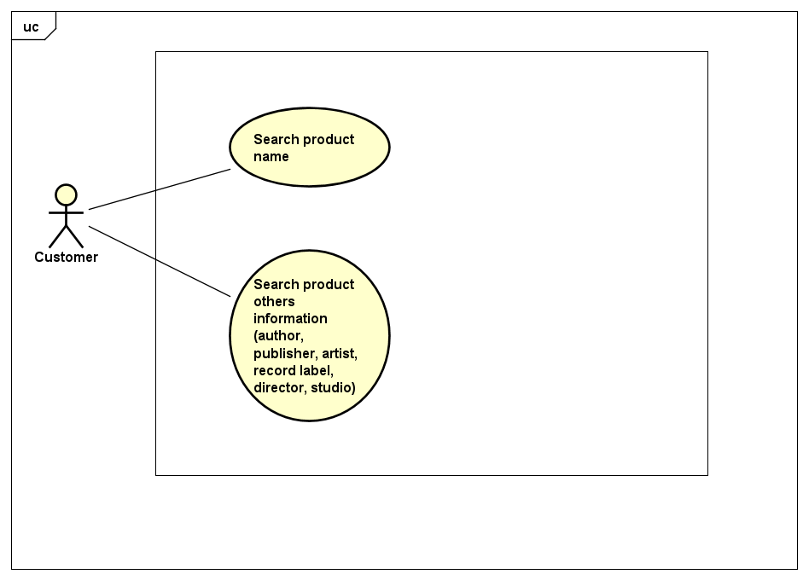

## Business processes

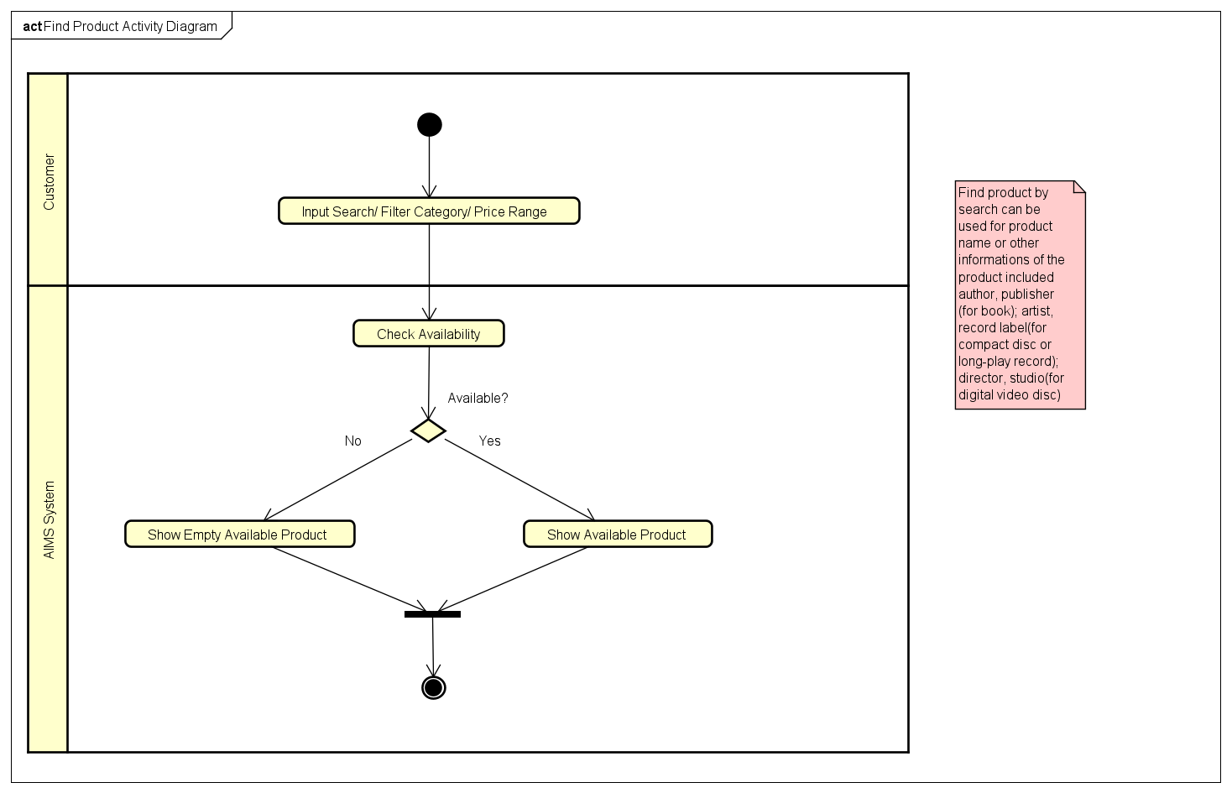

# Detail requirements

Details of the use cases given in following sections are specified below.

## Specification of Use case UC001 - “<Use case Find product by category>”

1. **Use case code**

UC001

1. **Brief Description**

This use case describes the interaction between customer and AIMS system when customer wish(es) to filter product by their category

1. **Actors**

Customer

1. **Preconditions**
2. **Basic Flow of Events**
3. The customer request to filter category of products include Book, Compact disc, Long-play record, digital video disc

2. The AIMS system checks the availability of products belong to selected categories

3. The AIMS system display the available products

1. **Alternative flows**

Table N-Alternative flows of events for UC Find product by category

|  |  |  |  |  |
| --- | --- | --- | --- | --- |
| **No** | **Location** | **Condition** | **Action** | **Resume location** |
|  | At Step 3 | If there is no products belong to selected categories | The AIMS system display no products available | End use case |

1. **Input data**

Table A-Input data of UC Find product by category

|  |  |  |  |  |  |
| --- | --- | --- | --- | --- | --- |
| **No** | **Data fields** | **Description** | **Mandatory** | **Valid condition** | **Example** |
|  | Selected categories | An array included categories is selected, can be empty array | Yes |  | [“BOOK”, “DVD”] |

1. **Output data**

Table B-Output data of UC Find product by category

|  |  |  |  |  |
| --- | --- | --- | --- | --- |
| **No** | **Data fields** | **Description** | **Display format** | **Example** |
|  | Available products | An array includes available products | An array in which each element is an object with product information | [{id: 1, title: “One Piece”, price:”20000”}] |

1. **Postconditions**

## Specification of Use case UC002 - “<Use case Find product by price range>”

1. **Use case code**

UC002

1. **Brief Description**

This use case describes the interaction between customer and AIMS system when customer wish(es) to filter products by price range

1. **Actors**

Customer

1. **Preconditions**
2. **Basic Flow of Events**

1. The customer request to filter products by price range

2. The AIMS system checks the availability of products belong to selected price range

3. The AIMS system display the available products

1. **Alternative flows**

Table N-Alternative flows of events for UC Find product by price range

|  |  |  |  |  |
| --- | --- | --- | --- | --- |
| **No** | **Location** | **Condition** | **Action** | **Resume location** |
|  | At Step 3 | If there is no products belong to selected price ranges | * The AIMS system display no products available | End use case |

1. **Input data**

Table A-Input data of UC Find product by price range

|  |  |  |  |  |  |
| --- | --- | --- | --- | --- | --- |
| **No** | **Data fields** | **Description** | **Mandatory** | **Valid condition** | **Example** |
|  | Selected ranges | An array includes selected ranges, can be empty array | Yes |  | [] |

1. **Output data**

Table B-Output data of UC Find product by price range

|  |  |  |  |  |
| --- | --- | --- | --- | --- |
| **No** | **Data fields** | **Description** | **Display format** | **Example** |
|  | Available products | An array includes available products | An array in which each element is an object with product information | [{id: 1, title: “One Piece”, price:”20000”}] |

1. **Postconditions**

## Specification of Use case UC003 - “<Use case Find product by search>”

1. **Use case code**

UC003

1. **Brief Description**

This use case describes the interaction between customer and AIMS system when customer wish(es) to filter products by search

1. **Actors**

Customer

1. **Preconditions**
2. **Basic Flow of Events**

1. The customer request to search products by keyword

2. The AIMS system checks the availability of products belong to selected keyword

3. The AIMS system display the available products

1. **Alternative flows**

Table N-Alternative flows of events for UC Find product by search

|  |  |  |  |  |
| --- | --- | --- | --- | --- |
| **No** | **Location** | **Condition** | **Action** | **Resume location** |
|  | At Step 3 | If there is no products belong to selected keyword | * The AIMS system display no products available | End use case |

1. **Input data**

Table A-Input data of UC Find product by search

|  |  |  |  |  |  |
| --- | --- | --- | --- | --- | --- |
| **No** | **Data fields** | **Description** | **Mandatory** | **Valid condition** | **Example** |
|  | Keyword | A string input by customer, can be empty string | Yes |  | “Harry” |

1. **Output data**

Table B-Output data of UC Find product by search

|  |  |  |  |  |
| --- | --- | --- | --- | --- |
| **No** | **Data fields** | **Description** | **Display format** | **Example** |
|  | Available products | An array includes available products | An array in which each element is an object with product information | [{id: 1, title: “One Piece”, price:”20000”}] |

1. **Postconditions**

# Supplementary specification

*<Presenting other requirements if necessary, including non-functional requirements such as performance, reliability, usability, and supportability; or other technical requirements such as database system, used technology…>*

## Functionality

<List of the functional requirements that are general to many use cases. E.g. Among the flow of events of use case, in all the steps that interacts with the database system, if there are errors in the connection or operation processes, there need to be a corresponding error notifications so that the actor knows that the error is related to the database system rather than the user>

## Usability

<Requirements that relate to, or affect, the usability of the software. Examples include ease-of-use requirements or training requirements that specify how readily the software can be used by its actors>

## Reliability

<Any requirements concerning the reliability of the software. Quantitative measures such as mean time between failure or defects per thousand lines of code should be stated>

## Performance

<The performance characteristics of the software. Include specific response times. Reference related use cases by name>

## Maintainability

<Any requirements that will enhance the supportability or maintainability of the software being built>

## Design Constraints

<Any design constraints on the software being built>